Self-Evaluation Form
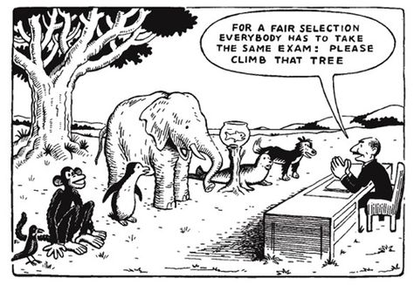
Name:

According to decades-worth of research, grades have a near-miraculous ability to demotivate students and keep them from engaging in the productive risk-taking learning requires. That is especially true for subjects like English, where grading is more subjective, and it is particularly perilous in a university system as diverse as CUNY’s. In an effort to keep the focus on learning, I created rubrics for your papers that were as specific as possible, and I gave you the option of resubmitting each paper up to three times. I also tried to keep the focus on in-class assignments that you will grade yourself.

Total points possible for this class = 233. Per the vote we conducted in class, the composition of your final grade is as follows. (Please note that you must complete all these assignments to pass, regardless of their point value):

In-class assignments and participation: 58% (up to 135 points)
Literacy narrative: 18% (up to 42 points)
Counternarrative: 18% (up to 42 points)
Rhetorical analysis: 4% (up to 9 points)
Mission Statement: 2% (up to 5 points)

Obviously, the in-class assignments count for a lot, and this score will be decided in collaboration. Essentially, you will give yourself a number value (between 0 and 135). Most of the time, I will accept whatever score you give yourself. Rarely, I will make adjustments, if I feel the grade you’ve given yourself is too high or (as is far more common) too low.

What matters most in assigning your score in this category (between 0 and 135 points) is the diligence you put into your in-class work. Did you come to class even when it was hard, even when you had to drag yourself there? Were you lazy with your responses to the in-class prompts or were you as thorough as you knew how to be? Did you contribute to the class discussion? Did you do your best to listen, to learn, and to grow as a writer and thinker? Did you make a good-faith effort to improve? Not for the sake of a grade, but for you?

Please tell me what number score (between 0 and 133) you think you deserve. Write a short paragraph explaining what makes this score accurate. Where did you struggle and where did you excel?

For reference:

A (between 127 and 133)
- (between 120 and 127)
B+ (between 113 and 119)
B (between 109 and 112)
- (between 106 and 108)
C+ (between 104 and 105)
C (between 97 and 103)
C- (between 93 and 96)

