Literacy Audit

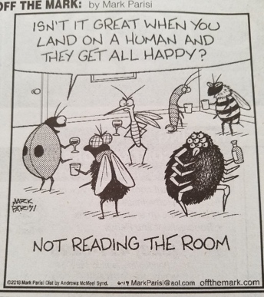

When most people hear the word “literacy,” they think of the ability to read and write. However, we use the word “literacy” to refer to competence in any area, as evidenced by the long list of possible “literacies”: technical literacy, financial literacy, business literacy, etc. You’ve probably heard the word “read” used in phrases like, “read the room,” “read the waves,” “read her face,” etc. Well, in its most general sense, literacy is the ability to read your environment and respond accordingly. You possess any number of literacies, and this is your opportunity to name them.

Write a list of every literacy you can think of that you possess. These may range from the more commonplace-- “TikTok literate,” “kitchen literate” --to highly niche literacies that apply only to you or a few people. Maybe you’re the only person in your family who can appease your brother’s anxiety, or maybe you’re a cat whisperer. Maybe you can diagnose what’s wrong with a car by the sounds it makes, or you can tiptoe silently across the squeaky living room floor. Believe it or not, these are all forms of literacy, when we apply the word in its most general sense.

When you’re done composing your list of literacies, choose a few of the more interesting ones and jot down your thoughts. Finally, choose the one you think would be the most fun to write about and write 500 words explaining how you acquired the ability, how you use it, and how it adheres to the broad definition of literacy given above (“the ability to read your environment and respond accordingly”).